Table of Contents

**Task 1.0 Construct the Design Steps** 2

**1.1** **Sequence** 2

Sequence Diagram Steps: 2

**Instance Sequence Diagram Steps:** 3

**Customer** 3

**Manager** 6

**1.2** **Activity** 9

**Activity Diagram Steps:** 9

**Activity Diagram for Business Modelling Steps** 9

**Activity Diagram for Use Case Modelling Steps** 10

**Task 2.0 Design the Diagram** 11

**2.1 Sequence Diagrams** 11

**2.2 Activity Diagrams** 13

# **Task 1.0 Construct the Design Steps**

## **Sequence**

## Sequence Diagram Steps:

1. Decide on the context of the interaction: system, subsystem, use case or operation

* I’m going to be designing a use case known as Restaurant Management System which will in theory enable both customers and manager to efficiently use it accordingly. This sequence diagram will consists of the following stakeholders and its features.

1. Identify the structural elements (classes or objects) necessary to carry out the functionality of the use case or operation

* The following object and classes belongs to the Restaurant Management System (RMS) which is also a point-of-sale (POS) software specifically designed for restaurants, bars, food tracks and others in the food service industry. Consisting of:
  + Customer
    - Customer
    - Restaurant System UI
    - Restaurant Kitchen
    - Account
    - Membership
    - Bank
  + Manager
    - Manager
    - Management System
    - Item Inventory
    - Menu
    - Member & Non-member promotion

1. Consider the alternative scenarios that may be required.

* Customer access his/her account with the wrong details.
* Manager access his/her account with the wrong details.
* Customer didn’t use the promotion.
* Customer can book a table or cancel bookings.

## **Instance Sequence Diagram Steps:**

### **Customer**

1. Layout the Objects from Left to Right.

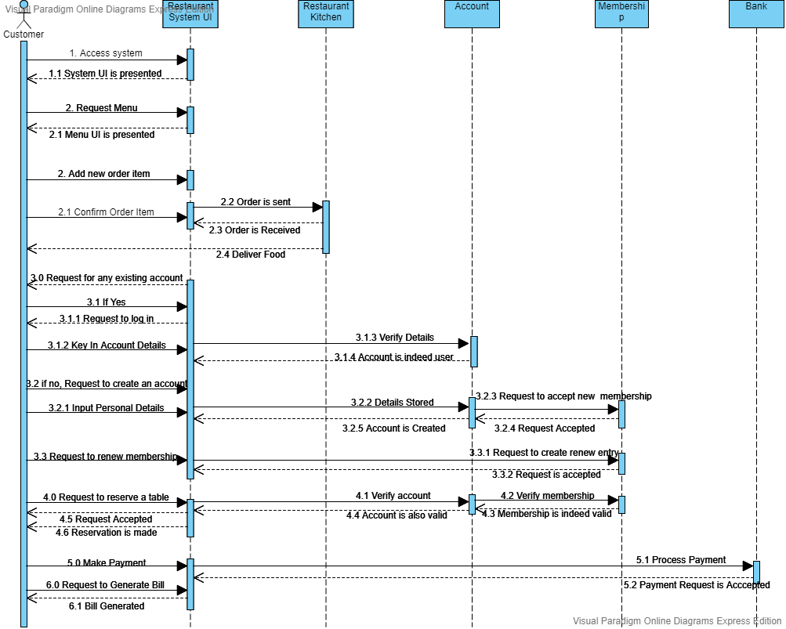

*Figure 1.0: Object involved.*

1. Layout Message Down the Page.
   1. Customer Initial Ordering Food Item Order.
   * Initially, customer will access system with a tap or a click. Only then will the system UI present itself and allow the customer to request for the menu. Upon seeing the menu, customer is free to choose their preferred food item and beverages and also choose to follow the promotion that was stated in the menu.
   * Once the customer has confirmed their food and beverages entries, only then will the order be processed and sent to the kitchen and after a while the food will be delivered to the customer accordingly.



*Figure 2.1: Customer Ordering Order*

* 1. Customer Account and Membership Creation
  + Whether the customer wishes to login now or wants to login later is entirely up to the user, as the system will still pop the question whether they have an existing account or not.
  + If customer has an existing account, they are free to key in their account details to see what bonus promotion they can get from being a member. They are also given the option to renew their membership if it has been a long while since they dine with that restaurant.
  + Customer also have a choice to whether they want to create an account, as having an account instantly makes you a member and allows more bonuses compared to having no account or non-members.



*Figure 2.0: Customer Account & Membership Creation*

* 1. Customer Booking
  + Customer who are members or account holders are allowed to make table bookings or reservation, then the system will first verify the account before asking for details about the booking, once the account is valid only then the customer may enter the necessary booking details. The system will register the booking schedule.
  + The customer can also cancel any bookings made in the system schedule. Provide account name or details and only then will the system or the staff will be able to find your booking and cancel the booking made.



*Figure: 2.2 Customer booking*

* 1. Customer Bill
  + After customer had their meals then they are proceeded to pay for it. Customer will then make payment depending on the customer payment method. The payment method is a bit different. If customer paid using card, the payment will be then be processed by the bank. After verifying the customer card and its validity only then the can the payment go through.
  + Also customer can also request for the bill or receipt and the system will generate the bill or the receipt accordingly.



*Figure: 2.2 Customer Bill*

### **Manager**

1. Layout the Objects from Left to Right.

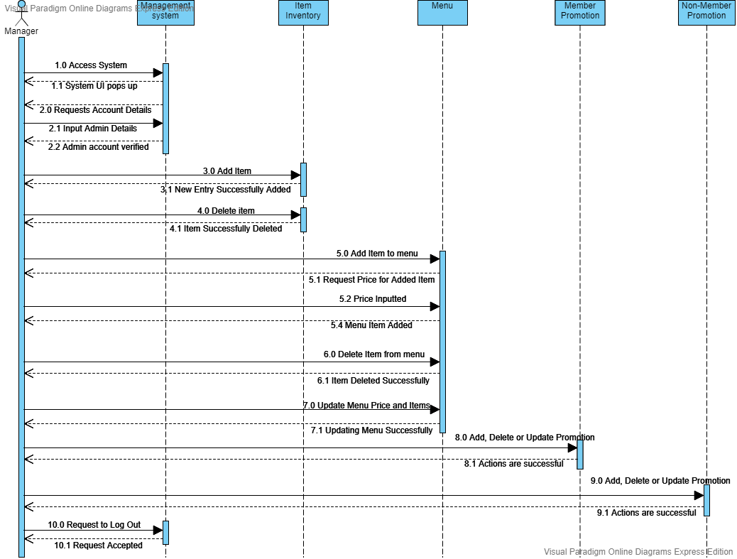

*Figure 3.0: Object involved*.

1. Layout Message Down the Page.
   1. Manager adding and deleting items for item inventory.
   * Managers must log in before performing any admin functions. Once the login is verified and login is valid, the manager can perform admin actions like adding or deleting items.



*Figure 4.0: Manager adding or deleting items*

* 1. Manager adding, editing or deleting a menu item.
  + Managers must log in before performing any admin functions. Once the login is verified and login is valid, the manager can perform admin actions like adding, editing or deleting items from the menu.
  + Every time the manager adds an item to the menu, he/she will be reminded to input the price for that specific food item or beverages. He is also free to edit or update any existing item stored or added to the menu previously.
  + Also manager must be careful when deleting items as you will have to re-add the item deleted again.
  + Also all actions done must be saved or updated in the system before logging out.



*Figure 4.1: Manager add, edit or delete menu item*

* 1. Manager adding, editing or deleting a promotion (Member & Non-Member).
  + Managers must log in before performing any admin functions. Once the login is verified and login is valid, the manager can perform admin actions like adding, editing or deleting promotion from the menu.
  + Every time the manager adds a promotion to the menu, he/she will be reminded to input the price or discount or promo for that specific food item or beverages. He is also free to edit or update any existing promotion stored or added to the menu previously.
  + Also manager must be careful when deleting items as you will have to re-add the item deleted again.
  + Also all actions done must be saved or updated in the system before logging out.



*Figure 4.2: Manager add, edit or delete promotion*

## **Activity**

## **Activity Diagram Steps:**

### **Activity Diagram for Business Modelling Steps**

1. Identify business actors and business use cases

* Manager
* Restaurant Management System

1. Identifying key scenarios of business use cases, using primary and alternative paths
   1. **Primary path**

* The manager accesses the system and the UI pops open.
* Manager then logs into the system, and select the option he wishes to perform action on.
* If manager logs in with invalid account detail, he/she has to retype the proper details again.
* After login is verified valid, only then will the following action is available. Once selected the option he wishes to perform action on, the manager then can perform administrative action like add, edit or delete.
* If manager wants to add, edit or delete promotion, he/she is advised to remember that promotion varies differently between members/account holders and non-members.
* After performing whatsoever action on the system, one must save to update the system before logging out.

### **Activity Diagram for Use Case Modelling Steps**

1. Identify actors

* Customer
* Restaurant Management System
* Bank

1. Identifying key scenarios of system use cases, using primary and alternative paths
   1. **Primary path**
   * The customer accesses the system and the UI pops open.
   * System request user whether they have an existing account or not, if yes then members can login normally. If not then they have a choice of creating an account or not.
   * When creating a new account, the system will input the data for the new account and also create a membership for the new account holder.
   * During login, if customer keys in the wrong account details they are forced to retry again.
   * Once logged in, customer has a few options to choose from, from either renewing their membership or request menu to order or booking reservation.
   * If customer chooses to order, then they are free to pick whatever they like and the system will then ask the customer to confirm on their order before it is process and pass to the kitchen.
   * After you are done with your order the system then shows promotion if the customer fails to see it inside the menu. The choice to use the promotion is optional.
   * If customer makes payment with card then the payment is then processed by the bank to verify its validity. If it’s valid the payment can go through and the bill can be generated accordingly.
   * Once payment is made, the customer will then receive their receipt.
   1. **Alternative paths**
   * Customer can make bookings for a table at any time and date.
   * Customer can cancel the booking by providing the necessary details. Once done, the system will inform the customer that the cancellation has been done.

# **Task 2.0 Design the Diagram**

## **2.1 Sequence Diagrams**

1. Customer Ordering, Account & Membership Creation, Bookings and Bill Payments



1. Manager Account, Adding, Editing or Deleting Item from Item Inventory, Menu Item or Promotion (Members &Non-Members).



## **2.2 Activity Diagrams**

1. Customer Login, Ordering, Renewing and Payment.

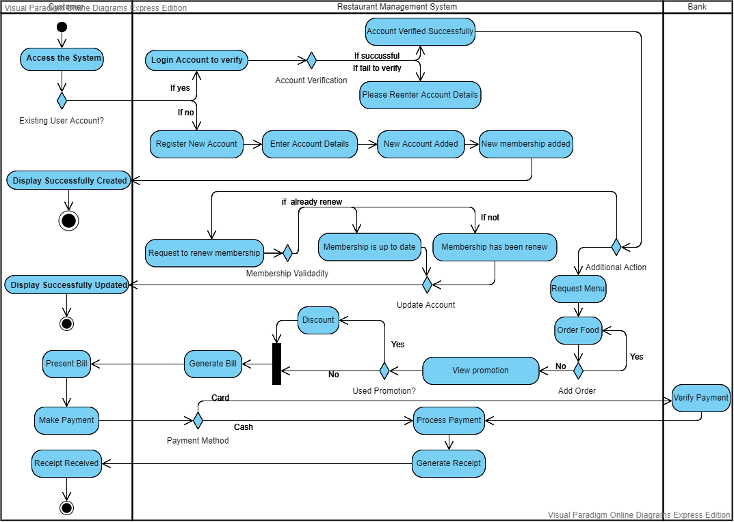

1. Customer Booking.

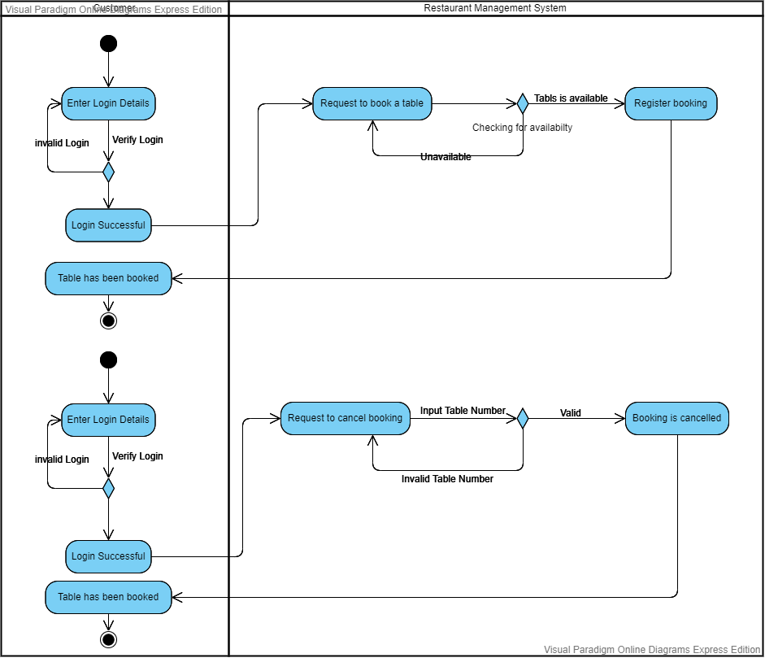

1. Manager Account, Adding, Editing or Deleting Item from Item Inventory, Menu Item or Promotion (Members &Non-Members).

